

**HEALTH PROMOTING SCHOOLS NEWSLETTER**

**JUNE 2015**

**INJURY PREVENTION**

**Teaching and Learning**

**June is Brain Injury Awareness Month**

Take a look at this great 6 minute video for kids, parents and coaches about [**concussions**](https://www.youtube.com/watch?v=zCCD52Pty4A&feature=youtu.be)

**NUTRITION**

|  |  |  |
| --- | --- | --- |
| |  |  | | --- | --- | | |  | | --- | | https://imgssl.constantcontact.com/letters/images/1101116784221/S.gif | | |

**Partnerships and Services**

**Hands-On Cook-Off Winners Announced!**

The sixth annual Hands-On Cook-Off contest challenge just wrapped up.

Check out the list of [**winners**](http://www.bettertogetherbc.ca/blog/single/announcing-our-2015-hands-on-cook-off-winners)**,** creative entries and yummy recipes from the young cooks who submitted inspiring home video cooking shows this year!

**POSITIVE MENTAL HEALTH**

**Partnerships and Services**

**WellAhead – A Social Innovation Lab Approach to Advancing Wellbeing in Schools**

The J.W. McConnell Family Foundation recently announced a new grant initiative to support child and youth wellbeing in the K­‐12 school setting. **WellAhead** is not a new program or organization – it is a process that brings together people from different perspectives - educators, students and parents alongside policy-makers, academics, practitioners and community partners - to collectively advance integrated approaches to social-emotional wellbeing in schools.

**WellAhead is seeking districts in BC that have a passion at the board, school and community level to advance students' social-emotional wellbeing.**

Webinars to further explain the initiative are planned for the following dates:

* **Wednesday, June 3rd from 7:30-8:30 am PST**
* **Thursday, June 4th from 3-4 pm PST**
* **Tuesday, June 9th from 6‐7 pm PST**

To register for a webinar click: [**here**](https://docs.google.com/forms/d/1Bddc5ok5zy0KvBrdyl8zhutaYQm54eD5CC3pU7B9pqk/viewform?usp=send_form) For more information about this opportunity click:[**here**](http://communityactioninitiative.us4.list-manage.com/track/click?u=48bb99e926d563ae502b915c4&id=ce386026b9&e=0d5b6d54e5)

**Teaching and Learning**

**PROMOTING MENTAL WELLNESS IN BC SCHOOL COMMUNITIES** - Summer Institute 2015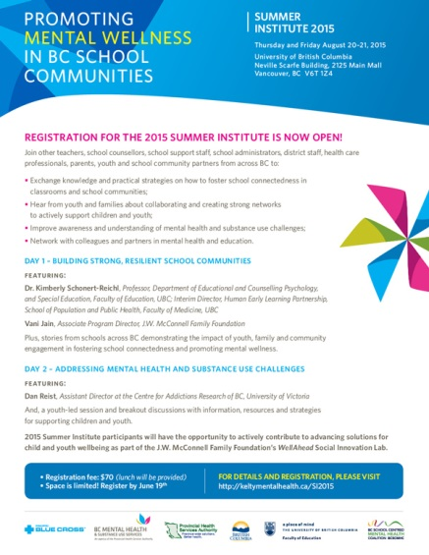

Topics: Building Strong, Resilient School Communities and Addressing Mental Health and Substance Use Challenges.

When: August 20-21, 2015

Where: UBC, Vancouver

For more information and how to register see:

[**http://keltymentalhealth.ca/si2015**](http://keltymentalhealth.ca/si2015)

|  |
| --- |
|  |

**POSITIVE SCHOOL ENVIRONMENTS**

**Social and Physical Environments**

Schools that structure their lunch break to have the children play first and eat second, report better behavior on the playground and in the classroom, better food and fluid intake by students, and less litter on the playground. For more information see:

the[**“Play First Lunch” toolkit**](http://healthyeatingatschool.ca/uploads/play-first-lunch-toolkit-september-2007-kr.pdf)

**TOBACCO REDUCTION**

**Teaching and Learning**

# Tobacco Use in Canada Trends 2015

With the release of the Canadian Tobacco, Alcohol and Drugs Survey, we have the first national data on e-cigarette use. Among those aged 15 and older, 9%, or 2.5 million people, said they had tried one. Rates among those aged 15 to 19 and 20 to 24 are more than twice that at 20%. Patterns and Trends has become a trusted resource for policy makers, public health professionals, and researchers seeking to find the most relevant and up-to-date information regarding tobacco use in Canada. To view the Patterns and Trends report and the supplement on Electronic cigarettes visit: [**http://www.tobaccoreport.ca/2015/**](http://www.tobaccoreport.ca/2015/) to download the two reports.

# Youth Resources

Looking for some interesting resources to share with youth? Visit: [**http://www.quitnow.ca/tools-and-resources/additional-resources.php#resources-for-youth**](http://www.quitnow.ca/tools-and-resources/additional-resources.php#resources-for-youth)

# Waterpipe Smoking

As more becomes known about the dangers of waterpipe (also known as hookah) smoking, both tobacco as well as other “herbal” concoctions, jurisdictions worldwide are responding with prohibitions in public places and workplaces.

The past two decades have seen it grow from a dwindling activity practised predominantly by older Middle Eastern men to become a youth-focused global epidemic. To read more about the waterpipe visit: [**https://www.nsra-adnf.ca/cms/file/files/Waterpipe-public_health_over_traditional_cultural_practices_2015-FINAL.pdf**](https://www.nsra-adnf.ca/cms/file/files/Waterpipe-public_health_over_traditional_cultural_practices_2015-FINAL.pdf)

**World No Tobacco Day**

One in every 10 cigarettes, and many other tobacco products, consumed worldwide are illegal, making the illicit trade of tobacco products a major global concern from many perspectives, including health, legal, economic, governance and corruption. The tobacco industry and criminal groups are among those who profit from the illegal tobacco trade, leaving the public to pay the health and security costs.

To learn more about the 2015 theme visit: [**http://www.who.int/campaigns/no-tobacco-day/2015/en/**](http://www.who.int/campaigns/no-tobacco-day/2015/en/)

## Letter to President Obama

A letter was sent to President Obama urged the Administration to finalize the Food and Drug Administration’s request to extend its authority over all unregulated tobacco products. While American in content this letter shows the need for e-cigarette regulations to protect marketing to children. View the letter [**HERE**](http://actiontoquit.org/wp-content/uploads/2015/04/Sign-on-letter-to-Pres-Obama-FDA-deeming-reg-4-28-15.pdf)**.**

**Partnerships and Services**

**IH Tobacco Contacts:**

Do you need to reach the Interior Health Tobacco Team?  **Email:** [**tobacco@interiorhealth.ca**](mailto:tobacco@interiorhealth.ca)

**For previous newsletters:** [**Health Promoting Schools Newsletters**](http://www.interiorhealth.ca/sites/Partners/SchoolDistricts/Pages/HealthPromotingSchoolsInitiative.aspx)

Or contact:

**Valerie Pitman**

**RN BN BSPsyc**

phone: 250-364-6221

email: [**valerie.pitman@interiorhealth.ca**](mailto:valerie.pitman@interiorhealth.ca)

**Knowledge Coordinator for Healthy Schools**

**IH Promotion and Prevention**

**Trail, B.C.**

***“Connecting health promotion staff with school staff to improve student’s health”***